Concordia University

Laboratory Report

COEN - 316

Lab – 3

Next Address

Submission Date: November 07, 2019

Prepared by

Salman Rahman 27853815

Name Student ID

“I certify that this submission is my original work and meets the Faculty's Expectations of Originality”

Contents

Figures 2

• Objective 3

• Introduction 3

• Conceptual Diagram of next_address unit 4

• Conclusion 4

• Results 5

o ModelSim Simulation of Next Address Unit: (please zoom in the figures if required) 5

o Precision log file 6

o RTL schematic and Tech schematic 8

o ALU.UCF file 9

o VHDL Code 10

# Figures

Figure 1 Conceptual diagram of the next_address uint 4

Figure 2 Simulation of next address unit is shown with different sets of inputs to test all the possible cases 5

Figure 3 Screenshot of tester do file 5

Figure 4 RTL schematic of the VHDL code 8

Figure 5 Tech schematic of the synthesis 8

* Objective

The objective of the lab was to design the hardware unit that calculates the next_adress of the program counter in VHDL.

* Introduction

The next_address calculated from the unit depends on multiple inputs from other components of the CPU. The next address depends on the following signals of the CPU:

1. Current PC value
2. PC select
3. Target Address
4. Branch type
5. Comparison between rs and rt values

There are several different branch operations that can be seen in the conceptual diagram of the next_address unit. The conditions and the logic of the branch instructions are summarized in the following tables:

|  |  |  |
| --- | --- | --- |
| **Instruction** | **Addressing Mode** | **Function** |
| Jump address | Pseudo-direct | Set PC to value of address |
| Jr rs | Register | Set PC to value of rs |
| Beq rs, rt, offset | PC-relative | Set PC to PC + 1 + sign_extend(offset) if rs = rt else PC + 1 |
| Bne rs, rt, offset | PC-relative | Set PC to PC + 1 + sign_extend(offset) if rs /= rt else PC + 1 |
| Bltz rs, offset | PC-relative | Set PC to PC + 1 + sign_extend(offset) if rs < 0 else PC + 1 |

|  |  |
| --- | --- |
| PC_sel | Function |
| 00 | Conditional branch (no jump) |
| 01 | Pseudo-direct jump |
| 10 | Jumps to value in register rs |
| 11 | Not used |

|  |  |  |
| --- | --- | --- |
| Branch_type | Meaning | Value to be added to pc |
| 00 | **No branch** | **1** |
| 01 | **Beq** | **If rs = rt: 1 + sign_extend(offset)**  **Else: 1** |
| 10 | **Bne** | **If rs /= rt: 1 + sign_extend(offset)**  **Else: 1** |
| 11 | **Bltz** | **If rs < 0: 1 + sign_extend(offset)**  **Else: 1** |

|  |  |  |
| --- | --- | --- |
| Branch_type | Meaning | Value to be added to pc |
| 00 | No branch | 1 |
| 01 | Beq | If rs = rt: 1 + sign_extend(offset)  Else: 1 |
| 10 | Bne | If rs /= rt: 1 + sign_extend(offset)  Else: 1 |
| 11 | Bltz | If rs < 0: 1 + sign_extend(offset)  Else: 1 |

* Conceptual Diagram of next_address unit

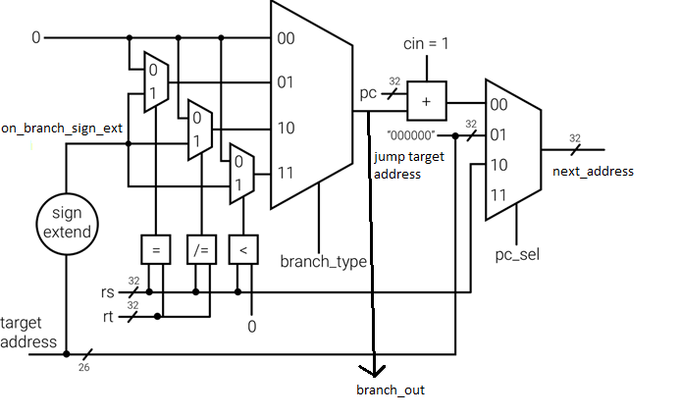

Figure 1 Conceptual diagram of the next_address uint

* Conclusion

In conclusion, the next_address unit was designed, tested and synthesized successfully in VHDL. This component allows the CPU to read the instructions from the memory and is a crucial part of the CPU.

* Results
  + ModelSim Simulation of Next Address Unit: (please zoom in the figures if required)

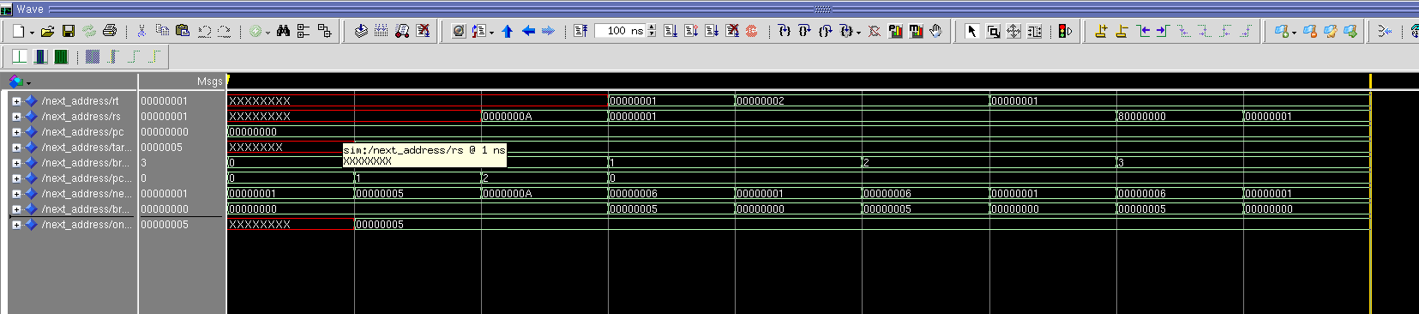

Figure 2 Simulation of next address unit is shown with different sets of inputs to test all the possible cases

The do file is shown below that was used to test the next_address unit:

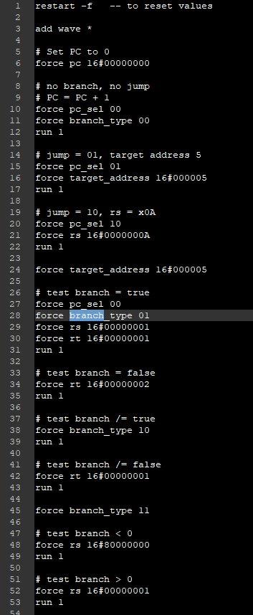

Figure 3 Screenshot of tester do file

The output of the next_address unit was as expected according to our conceptual diagram.

* + Precision log file

# Info: [9566]: Logging session transcript to file /nfs/home/s/sal_rahm/316/fpga_adv/lab3/precision.log

// Precision RTL Synthesis 64-bit 2016.1.0.15 (Production Release) Wed Jun 8 09:35:56 PDT 2016

//

// Copyright (c) Mentor Graphics Corporation, 1996-2016, All Rights Reserved.

// Portions copyright 1991-2008 Compuware Corporation

// UNPUBLISHED, LICENSED SOFTWARE.

// CONFIDENTIAL AND PROPRIETARY INFORMATION WHICH IS THE

// PROPERTY OF MENTOR GRAPHICS CORPORATION OR ITS LICENSORS

//

// Running on Linux sal_rahm@poise.encs.concordia.ca #1 SMP Thu Oct 17 14:34:42 CDT 2019 3.10.0-1062.4.1.el7.x86_64 x86_64

//

// Start time Thu Nov 7 03:14:10 2019

# -------------------------------------------------

# Info: [9566]: Logging session transcript to file /nfs/home/s/sal_rahm/316/fpga_adv/lab3/precision.log

# COMMAND: new_project -name lab3 -folder /nfs/home/s/sal_rahm/316/fpga_adv/lab3 -createimpl_name lab3_impl_1

# Info: [9574]: Input directory: /nfs/home/s/sal_rahm/316/fpga_adv/lab3

# Info: [9569]: Moving session transcript to file /nfs/home/s/sal_rahm/316/fpga_adv/lab3/precision.log

# Info: [9555]: Created project /nfs/home/s/sal_rahm/316/fpga_adv/lab3/lab3.psp in folder /nfs/home/s/sal_rahm/316/fpga_adv/lab3.

# Info: [9531]: Created directory: /nfs/home/s/sal_rahm/316/fpga_adv/lab3/lab3_impl_1.

# Info: [9554]: Created implementation lab3_impl_1 in project /nfs/home/s/sal_rahm/316/fpga_adv/lab3/lab3.psp.

# Info: [9575]: The Results Directory has been set to: /nfs/home/s/sal_rahm/316/fpga_adv/lab3/lab3_impl_1/

# Info: [9566]: Logging project transcript to file /nfs/home/s/sal_rahm/316/fpga_adv/lab3/lab3_impl_1/precision.log

# Info: [9566]: Logging suppressed messages transcript to file /nfs/home/s/sal_rahm/316/fpga_adv/lab3/lab3_impl_1/precision.log.suppressed

# Info: [9550]: Activated implementation lab3_impl_1 in project /nfs/home/s/sal_rahm/316/fpga_adv/lab3/lab3.psp.

new_project -name lab3 -folder /nfs/home/s/sal_rahm/316/fpga_adv/lab3 -createimpl_name lab3_impl_1

# COMMAND: add_input_file {../../32-bit-CPU/next_address.vhd}

add_input_file {../../32-bit-CPU/next_address.vhd}

# COMMAND: setup_design -manufacturer Xilinx -family "VIRTEX-II Pro" -part 2VP30ff896 -speed -7

# Info: [15298]: Setting up the design to use synthesis library "xcv2p.syn"

# Info: [575]: The global max fanout is currently set to 10000 for Xilinx - VIRTEX-II Pro.

# Info: [15324]: Setting Part to: "2VP30ff896".

# Info: [15325]: Setting Process to: "7".

# Info: [7512]: The place and route tool for current technology is ISE.

setup_design -manufacturer Xilinx -family "VIRTEX-II Pro" -part 2VP30ff896 -speed -7

# COMMAND: setup_design -frequency 100 -max_fanout=10000

# Info: [575]: The global max fanout is currently set to 10000 for Xilinx - VIRTEX-II Pro.

setup_design -frequency 100 -max_fanout=10000

# COMMAND: compile

# Info: [3022]: Reading file: /CMC/tools/mentor/precision/Mgc_home/pkgs/psr/techlibs/xcv2p.syn.

# Info: [634]: Loading library initialization file /CMC/tools/mentor/precision/Mgc_home/pkgs/psr/userware/xilinx_rename.tcl

# Info: XILINX

# Info: [40000]: vhdlorder, Release 2016a.7

# Info: [40000]: Files sorted successfully.

# Info: [40000]: hdl-analyze, Release RTLC-Precision 2016a.7

# Info: [42502]: Analyzing input file "/nfs/home/s/sal_rahm/316/fpga_adv/lab3/../../32-bit-CPU/next_address.vhd" ...

# Info: [659]: Top module of the design is set to: next_address.

# Info: [657]: Current working directory: /nfs/home/s/sal_rahm/316/fpga_adv/lab3/lab3_impl_1.

# Info: [40000]: RTLC-Driver, Release RTLC-Precision 2016a.7

# Info: [40000]: Last compiled on Jun 2 2016 06:11:46

# Info: [44512]: Initializing...

# Info: [44504]: Partitioning design ....

# Info: [40000]: RTLCompiler, Release RTLC-Precision 2016a.7

# Info: [40000]: Last compiled on Jun 2 2016 06:47:43

# Info: [44512]: Initializing...

# Info: [44522]: Root Module work.next_address(next_address_arch): Pre-processing...

# Info: [44523]: Root Module work.next_address(next_address_arch): Compiling...

# Info: [44846]: Rebalanced Expression Tree...

# Info: [44842]: Compilation successfully completed.

# Info: [44841]: Counter Inferencing === Detected : 1, Inferred (Modgen/Selcounter/AddSub) : 0 (0 / 0 / 0), AcrossDH (Merged/Not-Merged) : (0 / 0), Not-Inferred (Acrossdh/Attempted) : (0 / 0), Local Vars : 1 ===

# Info: [44856]: Total lines of RTL compiled: 57.

# Info: [44835]: Total CPU time for compilation: 0.0 secs.

# Info: [44513]: Overall running time for compilation: 1.0 secs.

# Info: [657]: Current working directory: /nfs/home/s/sal_rahm/316/fpga_adv/lab3/lab3_impl_1.

# Info: [15330]: Doing rtl optimizations.

# Info: [660]: Finished compiling design.

compile

# COMMAND: synthesize

# Info: [657]: Current working directory: /nfs/home/s/sal_rahm/316/fpga_adv/lab3/lab3_impl_1.

# Info: [15002]: Optimizing design view:.work.next_address.next_address_arch

# Info: [3027]: Writing file: /nfs/home/s/sal_rahm/316/fpga_adv/lab3/lab3_impl_1/next_address.edf.

# Info: [3027]: Writing file: /nfs/home/s/sal_rahm/316/fpga_adv/lab3/lab3_impl_1/next_address.ucf.

# Info: [660]: Finished synthesizing design.

# Info: [11019]: Total CPU time for synthesis: 0.8 s secs.

# Info: [11020]: Overall running time for synthesis: 1.0 s secs.

synthesize

# COMMAND: exit -force

# Warning: [9526]: Discarded unsaved work in implementation lab3_impl_1.

# Info: [9530]: Closed project: /nfs/home/s/sal_rahm/316/fpga_adv/lab3/lab3.psp.

close_project -discard

exit -force

* + RTL schematic and Tech schematic

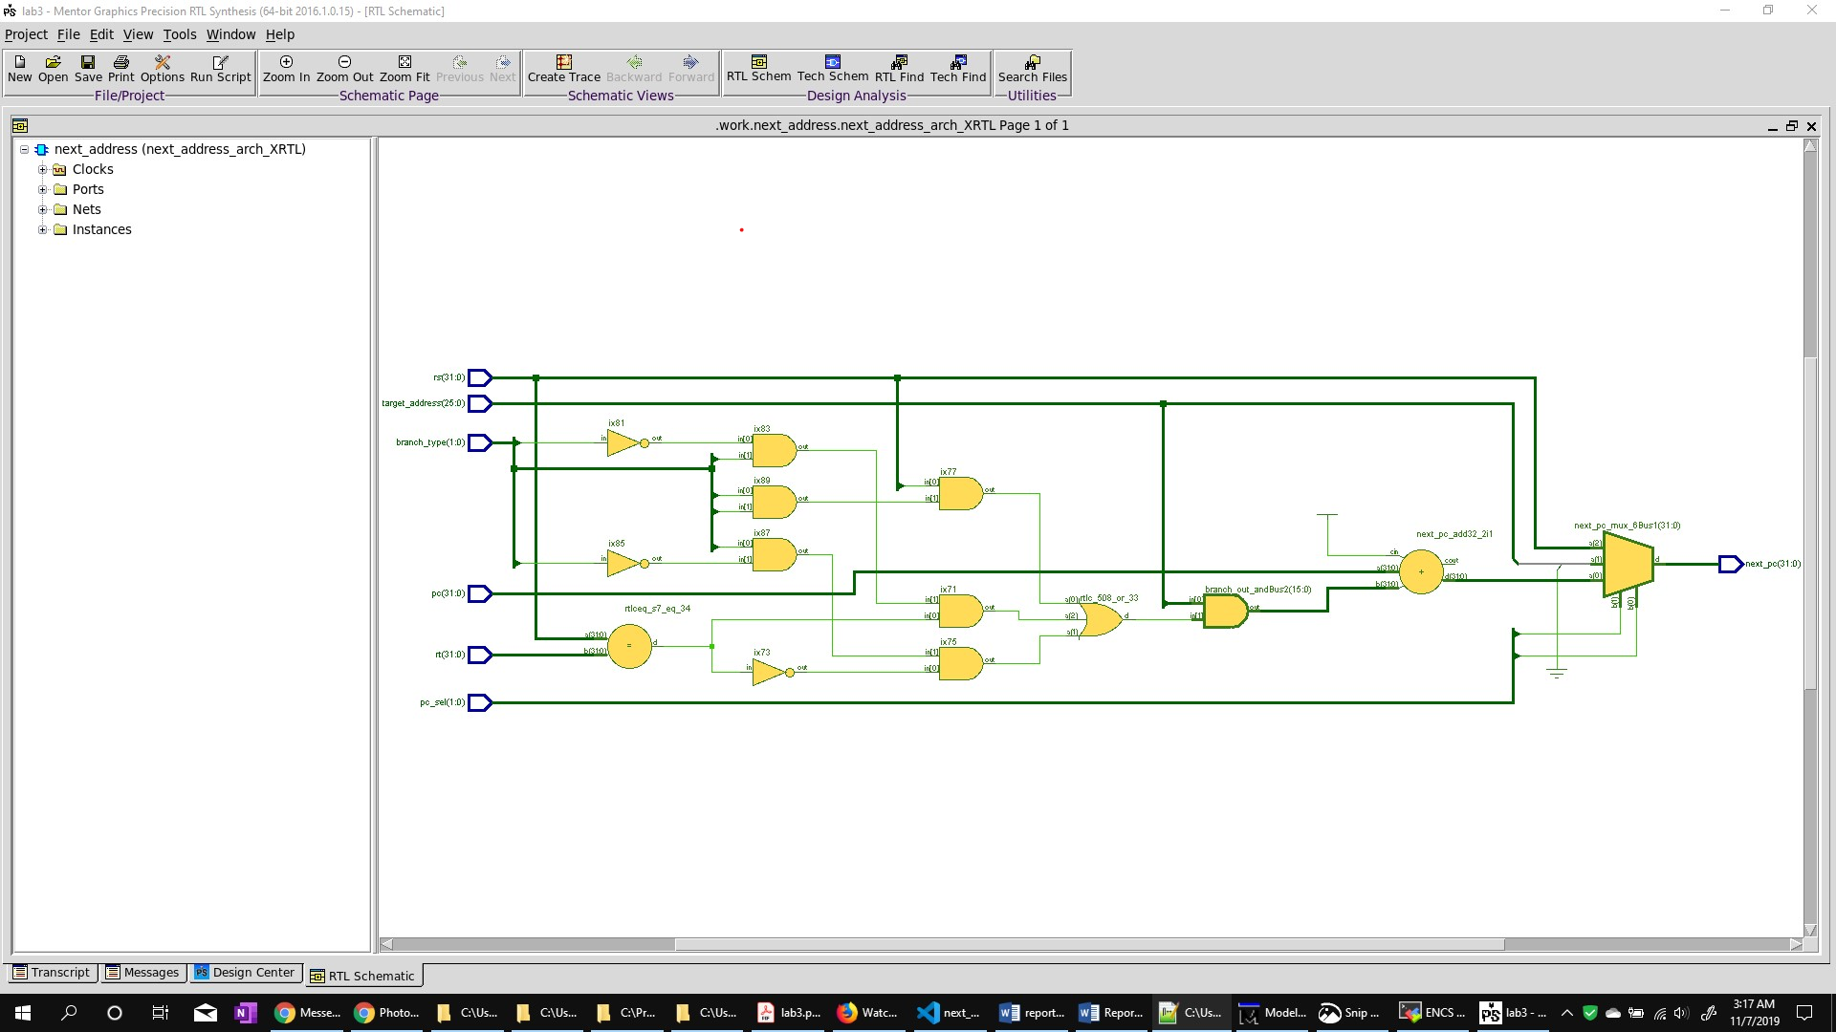

Figure 4 RTL schematic of the VHDL code

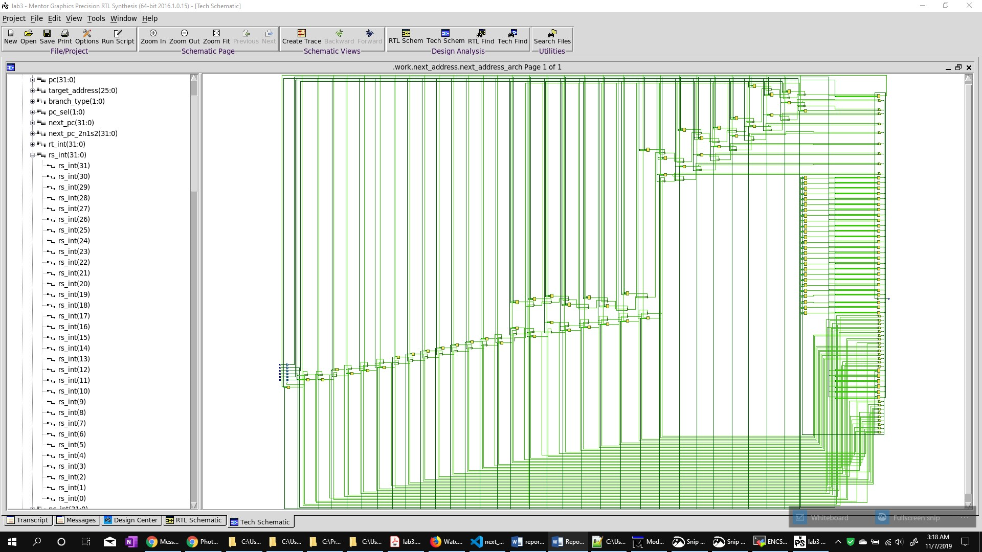

Figure 5 Tech schematic of the synthesis

* + ALU.UCF file

# Precision RTL Synthesis 64-bit 2016.1.0.15 (Production Release) Wed Jun 8 09:35:56 PDT 2016

CONFIG STEPPING="0";

NET next_pc (0) LOC = T6;

NET next_pc (1) LOC = V1;

NET next_pc (2) LOC = R3;

NET next_pc (3) LOC = R5;

NET next_pc (4) LOC = T2;

NET next_pc (5) LOC = P4;

NET next_pc (6) LOC = R7;

NET next_pc (7) LOC = P2;

* + VHDL Code

-- next address calculation unit

library ieee;

use ieee.std_logic_1164.all;

use ieee.std_logic_signed.all;

entity next_address is

port(

    rt, rs          : in std_logic_vector(31 downto 0);

    pc              : in std_logic_vector(31 downto 0);

    target_address  : in std_logic_vector(25 downto 0);

    branch_type     : in std_logic_vector(1 downto 0);

    pc_sel          : in std_logic_vector(1 downto 0);

    next_pc         : out std_logic_vector(31 downto 0)

);

end next_address;

architecture next_address_arch of next_address is

    signal branch_out: std_logic_vector(next_pc'length-1 downto next_pc'right);

    signal on_branch_sign_ext: std_logic_vector(next_pc'length-1 downto next_pc'right);

    begin

        on_branch_sign_ext((target_address'length-1)-(5+5) downto target_address'right) <= target_address((target_address'length-1)-(5+5) downto target_address'right);

        on_branch_sign_ext(next_pc'length-1 downto target_address'length-(5+5)) <= (others => target_address((target_address'length-1)-(5+5)));

        branch_select: process(on_branch_sign_ext, rs, rt, branch_type)

        begin

            branch_out <= (others=>'0');

            case branch_type is

                when "00" =>

                    branch_out <= (others=>'0');

                when "01" =>

                    if(rs = rt) then

                        branch_out <= on_branch_sign_ext;

                    end if;

                when "10" =>

                    if(rs /= rt) then

                        branch_out <= on_branch_sign_ext;

                    end if;

                when "11" =>

                    if(rs < 0) then

                        branch_out <= on_branch_sign_ext;

                    end if;

                when others =>

                    branch_out <= (others=>'U');

            end case;

        end process;

        pc_select: process(pc, branch_out, target_address, rs, pc_sel)

        begin

            case pc_sel is

                when "00" =>

                    next_pc <= pc + branch_out + 1;

                when "01" =>

                    next_pc <= "000000" & target_address;

                when "10" =>

                    next_pc <= rs;

                when others =>

                    next_pc <= (others => 'U');

                    --  11 is unused

            end case;

        end process;

end next_address_arch;